Requirements
- Protocol: Start with SNMPv1 (fast, tiny)
- Function: Support only GET for one OID
- Value: Unique ID That SNMP server will return when Macmon sends a GET request for your OID.
- Decision (Macmon side): If token matches the taught value → stay on Wi-Fi; else isolate.
- Constraints: Extremely small footprint, low memory/CPU, no external heavy libs.
Small footprint:
- Use minimal memory (tiny buffers, no heavy structures).
- Keep CPU load low (avoid complex loops or encryption).
- Ensure binary size is small for limited storage.
No heavy external libraries:
- Don’t use full SNMP stacks or OpenSSL.
- Implement only what’s needed:
- SNMPv1 GET handler for one OID.
- Simple BER parsing and response builder.
Practical approach:
- Write a custom lightweight SNMP responder.
- Use built-in Winsock for UDP networking.
- Use basic C functions for encoding/decoding
- Generate token with a tiny hash (FNV-1a or CRC32) instead of heavy crypto.

- OS: use Winsock (UDP/161).

Architecture

(how it fits our current main.c)
We have already:
- parse parameters → InitData
- start MyApp (&InitData)
- wait on ghExitEvent or keyboard to exit
- call _MyApp (&InitData) to clean up
We’ll add a light SNMP agent thread:
main.exe
└─ MyApp (&InitData)
├─ SnmpLight_Start(&InitData, ghExitEvent) <-- NEW
│ └─ thread: bind UDP/161, handle SNMP GET for one OID
└─ [...existing logic ...]
└─ on exit: └─ SnmpLight_Stop ()

The SNMP thread listens on UDP port 161 (SNMP), decodes GET for the one OID, and sends a GetResponse with your token.
It cleanly exits when ghExitEvent is signalled (or when you call Main_AppExit()).

Architecture diagram
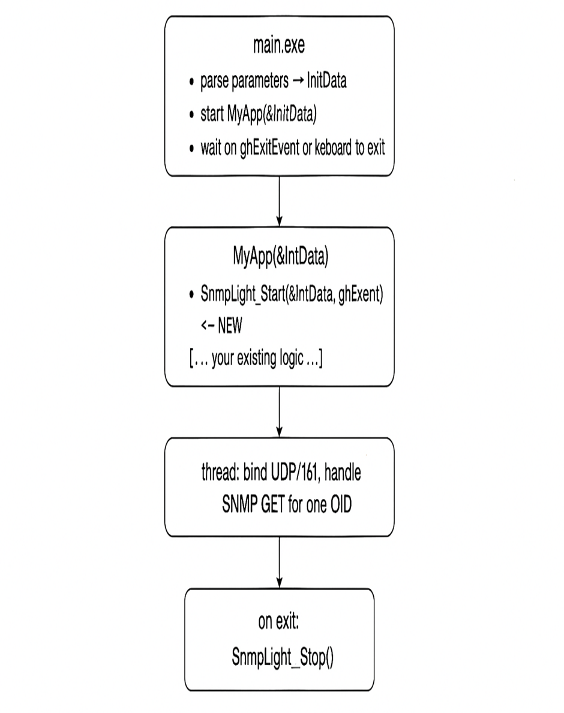

Working

- Start the Autoca Program (main.exe)
  - The controller starts the main program.
  - It reads configuration parameters (like car number, IP, etc.) into InitData.
- Run the Main Application (MyApp(&InitData))
  - This is your existing logic that controls the baggage handling car.
  - New addition: Start the SNMP agent by calling SnmpLight_Start(&InitData, ghExitEvent).
- SNMP Agent Thread
  - A small background thread is created.
  - It opens UDP port 161 (standard SNMP port).
  - It waits for SNMP GET requests from Macmon.
  - When Macmon asks for the OID, the thread responds with the unique token (your car’s ID).
- Exit Handling
  - When the system shuts down (or ghExitEvent is triggered), the SNMP thread stops cleanly using SnmpLight_Stop().

